State Leadership Conference
Sponsorship Opportunities

Conference Materials
Conference Programs Each attendee will receive a program with listings of the speakers, schedule, sponsors and contributors. $2,000
Awards HOSA rewards its members for their accomplishments, community service, and winning competitive events. Help Louisiana HOSA recognize these students and teachers. $1,500
Judge Gifts HOSA counts on local health professionals who volunteer to help judge many of the 56 competitive events. Help HOSA recognize these judges with a small & meaningful gift. $500
Judges/Speakers Food During the day, judges and workshop presenters appreciate a snack to keep them going. $500
Lanyards Add your company logo and see it around the neck of all attendees. $500
Already Purchased
Badge Holders All Attendees at the conference are required to wear name badges during the conference. Most students also place their schedule and room key in the holder $500
Already Purchased

General Session Sponsorship

HOSA has General Sessions that are available for your sponsorship. $2,000
Opening During the Opening Session, members experience a high energy and impactful session with a guest speaker. $2,000

Recognition During the Awards Session, members receive recognition for their efforts all year, and find out the results of the Competitive Events Program $2,000

It will cost approximately $7,500 per meal to feed the attendees.

Any portion that can be donated will be helpful or sponsor one whole meal.

Members Breakfast (2)
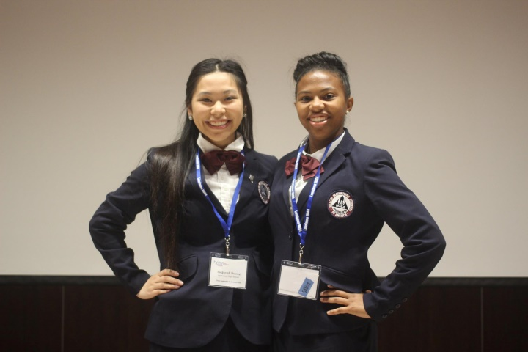
Lunch for Attendees (2)
Dinner for Attendees (1)

All sponsored materials or meals will be listed in the Conference Program, and on our website. In addition, sponsorships for sessions will be announced at the start of each meal. The sponsor will be offered the opportunity to bring greetings (2-3 minutes) at the opening or closing session or during the meal they sponsor.
Donations of any size are greatly appreciated. All donations are tax deductible.

